  
Raspberry Pi Wifi Access Point Documentation

### Contactless Temperature Monitor

Robbie Andersen, Kai Bushby, Mitch Stevens

## Summary

Controlling the Kobuki close range using a laptop and USB cable can be an uncomfortable experience for the user. Fortunately there is a project called RaspAP which allows setting up a Raspberry Pi to function as a Wifi Hotspot with ease. The projects main goal of to get the Raspberry Pi to act as an Wifi Access point, in our case we would only need the Wifi Hotspot feature as Kobuki will not require an internet connection to function.

## Equipment

* Raspberry Pi 3 / 4 loaded with Ubuntu 16.04

## Method

1. Interface into the Raspberry Pi and open up the terminal and run this command.  
   **$** wget -q https://git.io/voEUQ -O /tmp/raspap && bash /tmp/raspap

This single command installs RaspAP and starts it automatically.

1. Since we are using Ubuntu 16.04 and RaspAP does not officially support Ubuntu 16.04 we have to do some workarounds. Firstly php7.4-cgi will have to be installed:

**$** sudo apt-get update

**$** sudo apt -y install software-properties-common

**$** sudo add-apt-repository ppa:ondrej/php

**$** sudo apt-get update

**$** sudo apt-get install php7.4-cgi software-properties-common

1. Since port 80, the port that is used to access RaspAP, is used up by ROS the port used for RaspAP will have to be changed.

**$** sudo nano /etc/lighttpd/lighttpd.conf  
Change the port from port 80 to your desired port other than 11511 (That will also be used by ROS).

## Configuration

RaspAP can be configured by either accessing <https://localhost>:<port> on the Raspberry pi or by searching the Raspberry pi's local IP address in a browser with a device connected to the same network as the Raspberry pi.

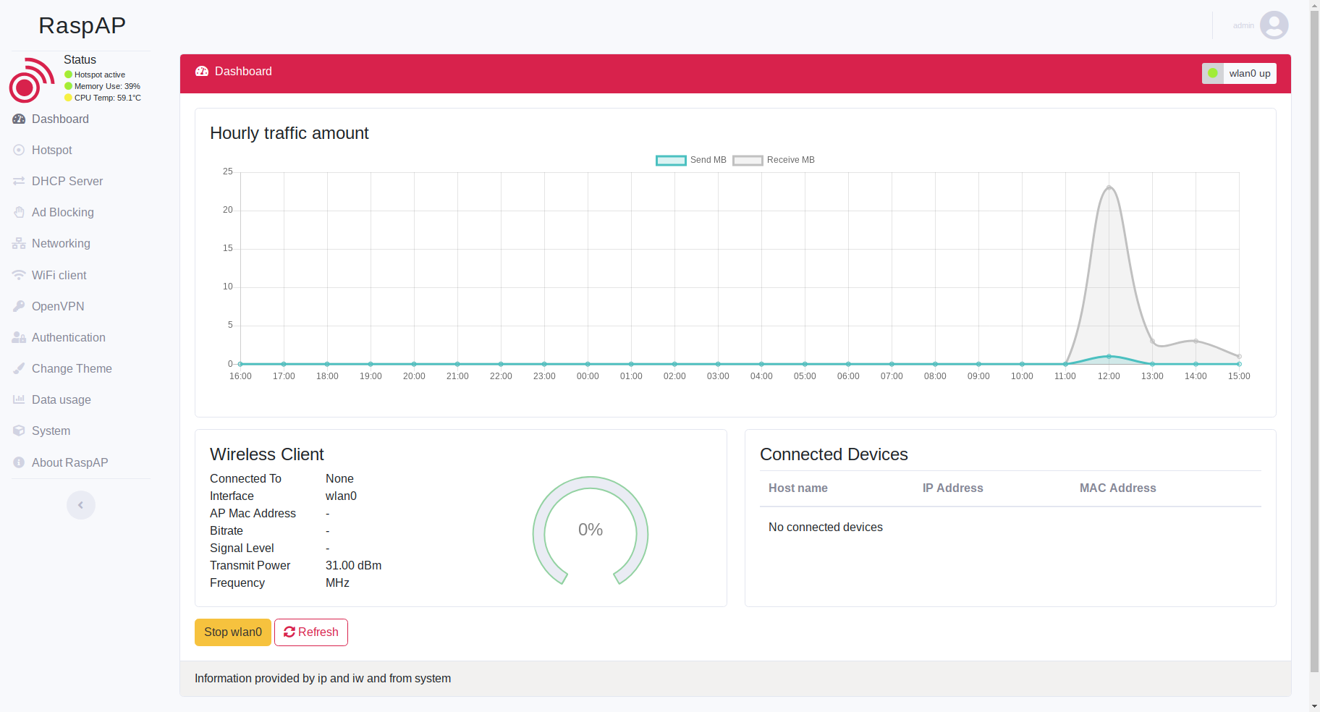

RaspAP - Dashboard

For this Kobuki project we will reconfigure the DHCP Server since the default addresses are 10.3.141.50 ~ 10.3.141.1.255 and it would be hard to remember such addresses. To compensate for the changes of the DHCP server, we will change the Gateways IP Address to something appropriate to that of the DHCP address range. This address will be used to access the Raspberry Pi.

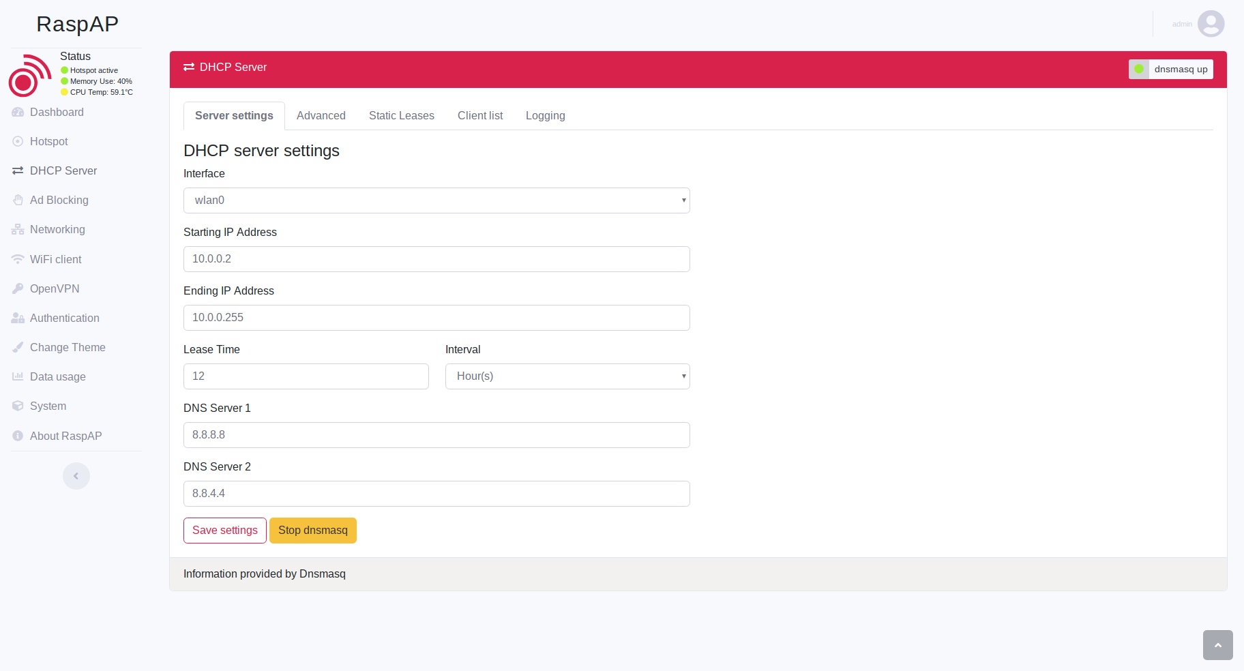

RaspAP - DHCP Server

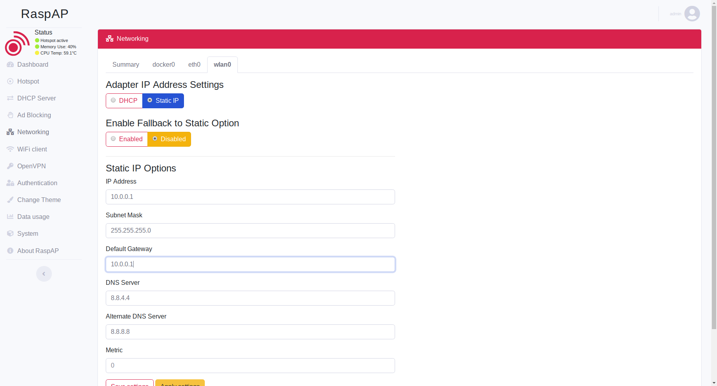

RaspAP - Networking

## Conclusion

The Raspberry Pi should now be able to be used as a wifi access point. Control of the Raspberry Pi is now available through a wireless network allowing for remote control. A wifi connection is also no longer needed to control the Kobuki but instead can be interfaced through this pseudo wifi-AP.